Problem 1 -> Array Merge

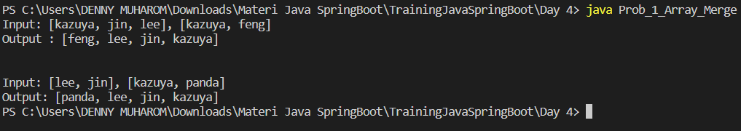

Problem 2 -> Angka Muncul Sekali

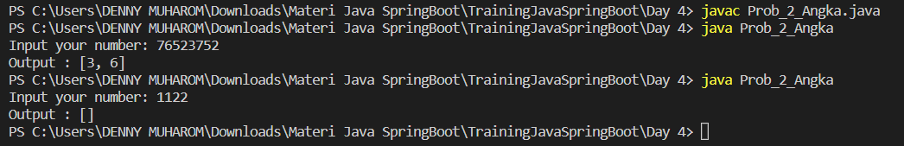

Problem 3 -> Pair with Target Sum

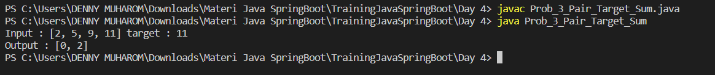

Problem 4 -> Array Unique



Problem 5 -> Remove Duplicates

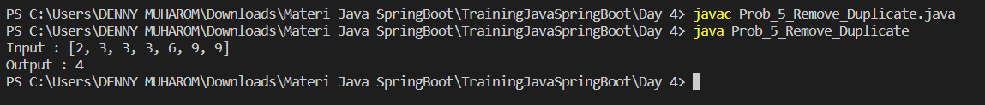

Problem 6 -> Maximum Sum SubArray of Size K (Optional / Nilai Tambah)

